

Eventing South Africa Business Plan

*Prepared by: Rob Ramsden*

*Updated: 15 April 2013*

**TABLE OF CONTENTS**

Executive Summary ....................................................................................................................1

Organisation Description ............................................................................................................3

Eventing as a Business ............................................................................................................3

Structure .................................................................................................................................3

Promoters and Shareholders..................................................................................................4

Board of Directors ..............................................................................................................4

Executive Committee .........................................................................................................4

CEO .....................................................................................................................................4

General Manager................................................................................................................4

Provincial Committees........................................................................................................4

Products and services .............................................................................................................5

Current Products ................................................................................................................5

Government Sport Classification ........................................................................................5

Future Developments & Products ......................................................................................6

Long Term Aims of Eventing SA ..............................................................................................6

Goals and Objectives ..............................................................................................................7

Immediate – 2 years ...........................................................................................................7

Short Term – 2 – 4 years.....................................................................................................7

Medium Term – 4 – 12 years..............................................................................................7

Long Term – 12 – 20 years..................................................................................................7

SWOT Analysis ............................................................................................................................8

Market Analysis ..........................................................................................................................9

International ...........................................................................................................................9

African – Group IX................................................................................................................ 10

National ............................................................................................................................... 11

South African Equestrian Structure ..................................................................................... 13

Eventing Market Analysis .................................................................................................... 14

Overview.......................................................................................................................... 14

Market Trends ................................................................................................................. 14

Benefits to Clients............................................................................................................ 14

Eventing Data 2011 – Entries per class............................................................................ 15

Eventing Data 2011 – Entries per grade .......................................................................... 16

Eventing Data 2011 – Entries per age group ................................................................... 16

Eventing Data 2012 – Entries per class............................................................................ 17

Eventing Data 2012 – Entries per grade .......................................................................... 18

Eventing Data 2012 – Entries per age group ................................................................... 18

Eventing Data Graphs – Entries per Age Group per year ................................................ 19

Eventing Data 2011 – Entries per Age Group .................................................................. 20

Eventing Data 2012 – Entries per Age Group .................................................................. 20

2011 & 2012 Provincial Entries Comparison ................................................................... 21

Market Data Analysis....................................................................................................... 22

Marketing/Sales Strategy ........................................................................................................ 24

Target Markets ................................................................................................................ 24

Research and Development .................................................................................................... 25

Business structure development - Portfolio structures .................................................. 25

New product development ............................................................................................. 29

Staffing and Operations........................................................................................................... 31

National Management Structure......................................................................................... 31

Management Organisation Chart .................................................................................... 31

Staffing Requirements ......................................................................................................... 31

Operations Requirements ................................................................................................... 32

Financial Projections................................................................................................................ 33

Revenue Sources ................................................................................................................. 33

Annual Subscription Model ............................................................................................. 33

Entry Levy Model ............................................................................................................. 33

Balanced Model ............................................................................................................... 34

Pricing Structure .................................................................................................................. 34

Pricing Influences ............................................................................................................ 34

Pricing .............................................................................................................................. 35

Yearly Subscription .......................................................................................................... 35

Entry Levies (per competition entry)............................................................................... 35

Lottery Funding ................................................................................................................... 36

Key Assumptions of cashflow model ................................................................................... 36

**EXECUTIVE SUMMARY**

This business plan puts forward the ideas for the future of Eventing in South Africa under the banner of **Eventing South Africa** (ESA) to achieve its vision. The implementation and governance of this plan is enshrined in the proposed Constitution of ESA.

The vision of ESA is:

• To achieve the involvement of as many equestrians, including previously disadvantaged and disabled, as possible in the sport of Eventing within all of the provinces of South Africa.

• To develop riders and horses from grass roots through to medal winning at

International competitions in the sport of Eventing.

• To assist all stakeholders to achieve maximum enjoyment and achievement from the sport of Eventing, irrespective of level of participation.

This business plan is based on the premise that management of the sport of Eventing requires a business focused management and administration model, with an emphasis on good governance and successful delivery.

To achieve this, a Board of Directors will be constituted, made up of Provincial representatives, elected by Members in that province and the positions of President, Technical Director, Financial Director and additional Director elected by Members of ESA. The Board of Directors will appoint a Chief Executive Officer (CEO), who will be responsible for the running of ESA and supported by a General Manager, who will be a paid employee.

The Board of Directors will appoint portfolio holders and members of sub-committees to carry out the objectives of ESA as required by the CEO.

ESA supports the Government’s National Vision of “An Active and Winning Nation” and this Business Plan proposes to do this via a structure of sporting levels; Elite, High Performance, Development and Talent Identification. This plan also highlights opportunities that are available for the growth of the sport.

This Business plan is supported by a SWOT analysis and market analysis for the sport of Eventing in South Africa and further commentary on the sport, both internationally and nationally.

Data for Eventing in South Africa over the last two years is presented and analysed.

A marketing/development strategy with areas requiring attention is presented, which gives sight of potential portfolios and sub committees.

Financial projections based on recent historical data are included, where membership and show attendance has been used to derive an income forecast and operating cost and start- up costs have been estimated.

Various income models are discussed. The philosophy used for revenue has been to keep membership fees low and increase levies from shows. But keep the total average costs paid by Eventers to be in-line with their current expenditure. This model hopefully will encourage riders to become Eventers and they will then pay according to the amount they participate. Horse registration will take into account the level of competition they are qualified for. Thus Eventers at the top level will be contributing to the increased costs of participation at FEI level and the increased course costs at this level.

For the first year of operation, revenue is estimated to be R745 100 and operating costs of

R646 500, with start-up costs of R40 500. This leaves a first year contingency of R58 100.

**ORGANISATION DESCRIPTION**

Eventing SA is the managing association of the sport of Eventing in South Africa.

**EVENTING AS A BUSINESS**

Several different management and administration models have been reviewed with careful consideration of the following factors:

• Economic viability

• Growth and Effectiveness

• Flexibility

• Good Governance

• Political impact

Given the above and the requirements of the new structure a sport business model was decided upon that balances the needs to the association with the management of the sport nationally as well as within the provinces.

**STRUCTURE**

The following structure is based on a 2 ½ (2/3) level business model rather than directly a 2 level or 3 level, which allows the business to change with the needs of the sport in the future.

Board of Directors

Executive Committee

GM CEO

Portfolio Portfolio Portfolio Portfolio Portfolio Portfolio

GP KZN WP EC MP FS

LP NC NW

Portfolio Portfolio Portfolio Portfolio Portfolio Portfolio

This allowed for the creation of a flexible constitution that binds the sport, but does not restrict its future growth.

**PROMOTERS AND SHAREHOLDERS**

The structure will be made up of the following individual positions.

**Board of Directors**

The board of directors is to be made up of:

• President

• Technical Director

• Financial Director

• Additional Director

• Chairman of Gauteng

• Chairman of Kwa-Zulu Natal

• Chairman of Western Province

• Chairman of Eastern Cape

• Chairman of Mpumalanga

• Chairman of Free State

• Chairman of Limpopo

• Chairman of Northern Cape

• Chairman of North West

Specific Director requirements:

• The Technical Director will be a current National Technical Delegate.

• The Financial Director will have a Chartered Accountant Degree or equivalent.

All Eventing SA members vote for the President, the Technical Director, the Financial Director and the Additional Director. Members within each of their provinces vote for their respective chairman.

The Board of Directors is a steering committee that maintains the alignment of the sport. The intention is that this committee does not get involved with the day to day of the business, but merely makes sure that the sport is going in the right direction.

**Executive Committee**

The executive committee is a non-voted committee that is appointed directly by the Board of Directors to implement the business of Eventing SA. At this point, only the CEO will be appointed to the Executive. Should the structure either grow or need changing in the future the presence of the Executive Committee allows an additional level of administration.

**CEO**

The Executive Committee always contains the CEO of Eventing, and other members can be appointed to the Executive by the Board of Directors.

**General Manager**

The General Manager will be employed / appointed by Eventing SA to manage the day to day administration and project management of the association.

**Provincial Committees**

Provincial committees will remain in a similar structure as they currently are now, however; they will need to accommodate new business direction in each of the provinces depending on the level of development and number of members.

**PRODUCTS AND SERVICES**

Eventing is an equestrian triathlon that combines three different disciplines in one competition set out over one, two, or three days, depending on the length of courses and number of entries. This makes it one of the most exciting and exhilarating equestrian sports for athletes to take part in and spectators to view.

**Current Products**

Currently there are 6 primary eventing products; FEI and National classes, which can further be broken down into sub-products:

• FEI

o 3* CIC & CCI

o 2* CIC & CCI

o 1* CIC & CCI

• National

o Ev100

o Ev90

o Ev80

FEI classes are primarily Adult & Young Rider athletes, and National classes cover Pony Rider, Junior and Adult athletes.

**Government Sport Classification**

The 2 primary governmental departments that manage sport are SASCOC (South African Sports Confederation and Olympic Committee) and SRSA (Sports and Recreation South Africa). SASCOC is the controlling body for all high performance sport in South Africa, and SRSA is the national government department responsible for sport in South Africa. Aligned with its vision of creating **An Active and Winning Nation**, its primary focuses are providing opportunities for all South Africans to participate in sport; managing the regulatory framework thereof, and providing funding for different codes of sport.

The National Vision of ‘**An Active and Winning Nation**’ relates well to the creation of an active base of athletes and participants that support the growth from within to create a winning nation. Both arms of the government fall well into this mantra with SRSA focusing on creating a broad base and SASCOC focusing on the pinnacle of Elite athletes competing internationally.

The structure can be broken down into:

• Elite

o International riders focused on winning medals. (SASCOC)

• High Performance

o Top performing riders that also have the capability to go on to win medals.

• Development

o Participation and development of athletes in the sport.

• Talent Identification (TID)

o Talent Identification occurs throughout the Development phase in identifying any athlete that has the potential to become a medal winning Elite athlete, and assisting that athlete to achieve their potential.

• Transformation

o Numbers of equestrians. (Riders not participating directly in competition).

o Previously disadvantaged.

o Disabled.

This can be roughly outlined and applied to Eventing in the following diagram, as well as to where the different levels fit into different regions.

Elite

High Performance

International 3* National 2*

1*

Development

TID

Provincial

Ev100

Ev90

Ev80

Transformation

Clubs / Riding

Schools

**Future Developments & Products**

Eventing as a sport needs modernisation in order to grow and prosper. There is significant growth potential within South Africa in multiple market segments.

• New grades

• Inter Club Team Competition

• Express Eventing

• One Day Series

• SANESA integration

**LONG TERM AIMS OF EVENTING SA**

Eventing has 2 primary aims that fall in line with the Governmental requirements in sport.

1. Medals

To achieve medal winning potential in World Equestrian Games (WEG) and the

Olympic Games (OG).

2. More participants

To increase the number of competitive Eventers in South Africa from the base up.

**GOALS AND OBJECTIVES**

The Goals and Objectives of Eventing will need to be re-evaluated each year, based on the success of the previous year. Goals need to be realistic and achievable so as to meet milestones to unlock governmental funding.

**Immediate – 2 years**

• Build a successful management system in order to manage the sport in South Africa.

• Create a portfolio system to develop all aspects of eventing.

• Broaden the competitor base by 15%.

• Build a sustainable communications infrastructure.

• Host a test run Group IX competition.

**Short Term – 2 – 4 years**

• Enter an International Cup of Nations team to compete against other National

Federations throughout each year.

• Broaden the competitor base by another 15%.

• Extend eventing into every province within South Africa.

• Host an eventing African Cup of Nations. (Group IX)

• Establish a base of operations in Europe to assist South African athletes in their transition to international competition.

**Medium Term – 4 – 12 years**

• Maintain on-going International Cup of Nations team competition.

• Achieve a top 20 placing in International competition.

• Achieve a consistent 10-15% growth in the competitor base year on year.

**Long Term – 12 – 20 years**

• Achieve a consistent 10-15% growth in the competitor base year on year.

• Achieve individual medals in International competition.

**SWOT ANALYSIS**

|  |  |
| --- | --- |
| **Strengths**  • One of the most exciting and fun equestrian sports.  • Passionate athletes and organisers.  • Internationally recognised Olympic sport.  • Athletes can represent South Africa.  • Have willing trained officials. | **Weaknesses**  • Perceived as a high skill sport.  • Perceived as a dangerous sport.  • Perceived as a lot of effort.  • Perceived as expensive.  • Based on a volunteer structure.  • Competitions are extensive and  expensive to organise and require a lot of effort and planning. |
| **Opportunities**  • International competition and medals.  • New national equestrian structure.  • New Provinces.  • New product development.  • SANESA  • Government assistance. | **Threats**  • Economics  o Riding sports are a luxury that is often cut back on in a depressed economic market.  • Modern instant society.  • Available time of volunteers.  • Choice in other disciplines.  • SANESA  • Legal – safety. |

**MARKET ANALYSIS**

The South African eventing market covers 4 main segments.

• International

• African

• National (South African)

• Provincial

Currently Eventing in South Africa primarily focuses on National and Provincial segments, with riders competing internationally.

**INTERNATIONAL**

The international segment is both inward and outward facing, with the FEI having assisted

South Africa in stepping onto the International stage, thus allowing our athletes to compete overseas.

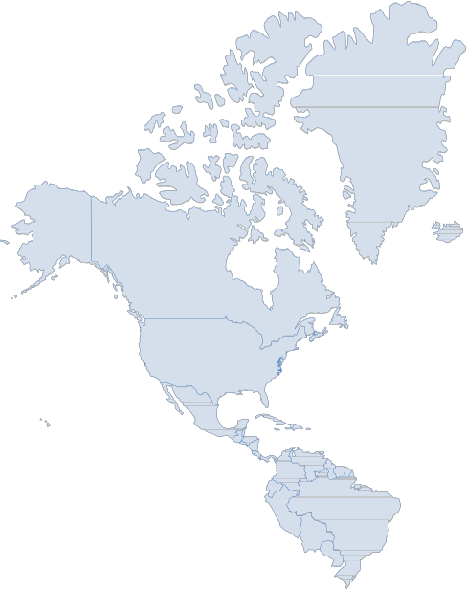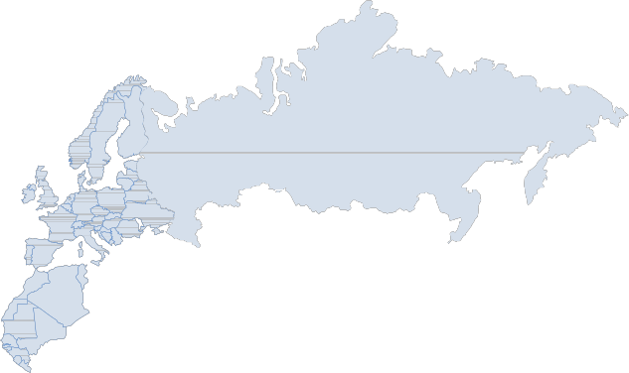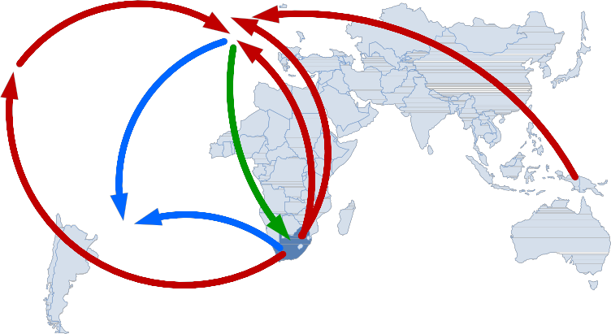

• FEI

o The FEI has given a significant amount of assistance to South African eventing in the funding and development of athletes, course construction

and officials development.

• FEI Eventing

o FEI Eventing management.

o There is a need to understand more on where South Africa fits within the worldwide FEI structure and goals.

• International Riders

Our international riders are aiming to compete for South Africa in either WEG or the Olympics and are based primarily in Europe, with some riders campaigning from New Zealand, Australia and USA.

o Europe

o New Zealand

o Australia

o USA

• WEG 2014, 2018, 2022, 2026, 2030

o 2014 - Normandy

• Olympics 2016, 2020, 2024, 2028, 2032

o 2016 - Rio

**AFRICAN – GROUP IX**

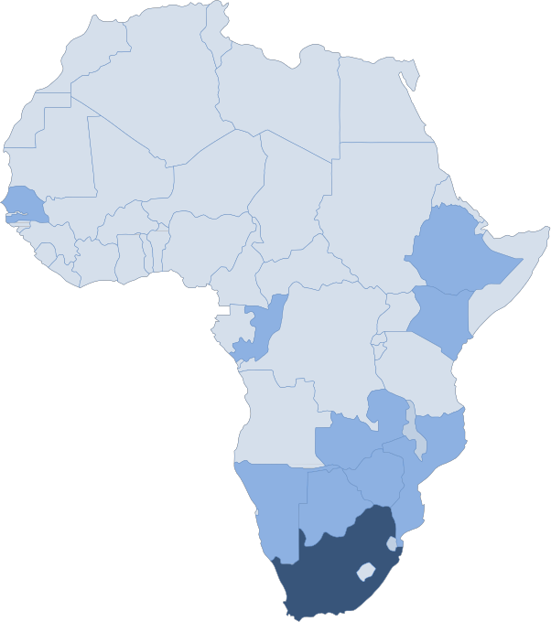

• FEI – Group IX

o South African FEI equestrian sports are part of the FEI Group IX grouping.

o South Africa has received the majority of funding from the FEI within the group to date.

o There is a perceived obligation to assist the rest of the Group IX countries where possible and as requested with spreading eventing through Group IX.

• Africa Nations Cup

o There is an opportunity in the future to host an Africa Nations Eventing Cup once grades and logistics can be structured.

**NATIONAL**

The local South African market is made up of several stakeholders that have direct influence over the sport of eventing in South Africa, as well as all of the individual provincial participants that each has unique flavours and requirements.

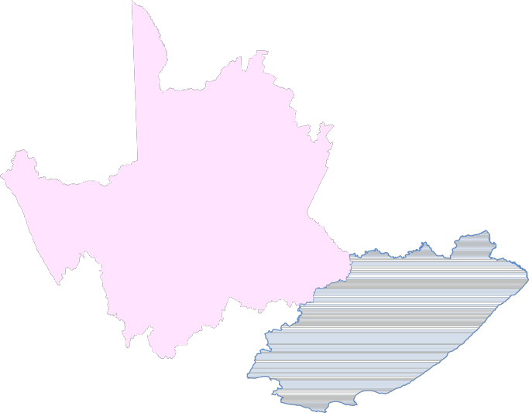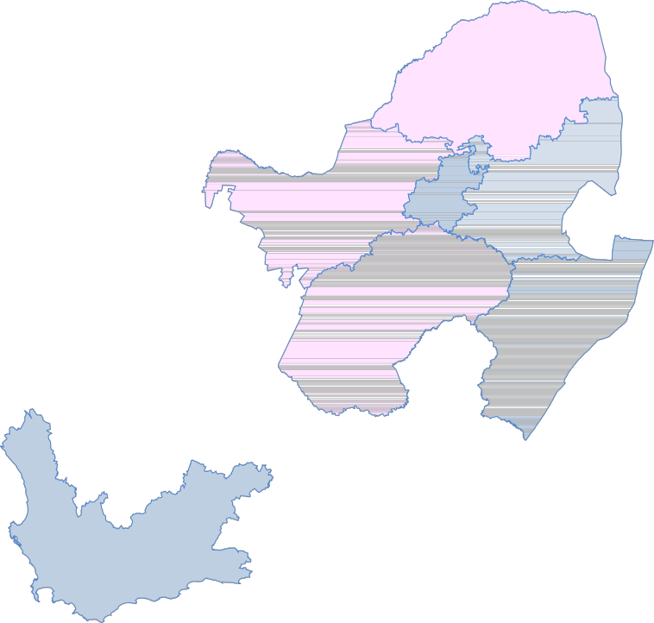

**Limpopo**

**North West Gauteng**

**Mpumalanga**

**Northern Cape**

**Free State**

**Kwazulu- Natal**

**Eastern Cape**

**Western Cape**

• SASCOC

o Deals primarily with elite and Olympic sport and is the ‘Winning’ part in the government ‘**An Active and Winning Nation**’ strategy.

• SRSA

o Deals primarily with mass participation in sport and is the ‘Active’ part in ‘**An**

**Active and Winning Nation**’.

• SAEF

o The South African Equestrian Federation is the official federation under

SASCOC.

o The Federation is governed by the rules and regulations as provided for in the Sports Act, and rules and regulations of the Federation Equestre Internationale (FEI) for the disciplines, which are FEI disciplines, the rules and regulations of other international Sporting parent bodies for those relevant equestrian disciplines, as well as the rules and regulations of SASCOC. The purpose of the federation is to assist all its members with the awarding of Protea National Colours to its members, obtaining funding or other assistance from Regulatory bodies for the benefit of itself and all its members, securing the support and or assistance of Regulatory Bodies for

• SANESA

the development of the equestrian sport by itself and its members, representing Equestrian Sport in negotiations with regulatory bodies and to ensure adherence of the Sport Act, rules and regulations of SASCOC and the Constitution of the Republic of South Africa by its members.

o Currently school sport is handled by the Government Education rather than SRSA. SANESA has formed the link through Education and therefore school equestrian sport currently goes through SANESA.

Provinces

• Gauteng

o Approximately 34.5% of all eventing in SA, with 10–11 competitions per year.

• Kwa-Zulu Natal

o Approximately 26.5% of all eventing in SA, with 8-10 competitions per year.

• Western Province

o Approximately 24.5% of all eventing in SA, with 7 competitions per year.

• Eastern Cape

o Approximately 14.5% of all eventing in SA, with 4-10 competitions per year.

• Mpumalanga

o Eventing is at grass roots with a handful of competitions each year.

• Free State

o New Eventing committee taking shape.

o Currently: Little to no eventing taking place.

• Northern Cape

o Little to no eventing taking place.

• North West

o Little to no eventing taking place.

• Limpopo

o Little to no eventing taking place.

**SOUTH AFRICAN EQUESTRIAN STRUCTURE**

The new South African equestrian market can loosely be outlined by the following diagram.

International

Olympics

WEG

NATIONAL EQUESTRIAN RELATIONSHIP DIAGRAM

FEI

International SA Riders

International Horse

National

National Government

SASCOC

South African

Equestrian Federation

SAEF National Office

Sport & Recreation

Discipline

Association A

Discipline

Association B

Discipline

Association...N

Education

SANESA

National

National

National

State Vet

Provincial

Provincial

Government

Provincial

Provincial

Provincial

Vet

SAEF Provincial Office

Officials

Instructors

Officials Instructors Officials Instructors

Club

Local Council

(Regional)

Club A

Club B Clubs… N

Horse

Non-Competing

Member

Competing Member

Lower Grade

Competing Member

Higher Grade

Development

Competing Member

**EVENTING MARKET ANALYSIS**

**Overview**

There are currently an estimated 10,000 active competitive equestrian athletes in South Africa (according to SAEF), with approximately 3,500 of them participating in English Riding disciplines (current SAEA disciplines).

Of the 3,500 SAEA athletes, approximately 450 participate in Eventing each year, which equates to approximately 4.5% of all competitive riders in South Africa, and approximately

12.85% of English Sport riders.

At this point, it’s very difficult to estimate the size of the total number of riders in South Africa that have not yet entered into competitive riding. This is estimated at a significant number of new athletes that could be enticed to join the sport of Eventing.

With the implementation of new Eventing products, many new athletes might be inclined to try the sport and then continue to participate at grades that they feel comfortable at.

**Market Trends**

The Equestrian market has changed significantly over the last 25 years, with riders not having access to the countryside rough and ready horsemanship of the past, and nor does new fast paced society allow the time that used to be available to riders, therefore there is a reduction in athlete skills which requires a different approach to products for the market.

The recent world economic downturn has also had significant impact on the numbers of competitors at competition in the last few years.

In addition the reduction in size of the South African Pony Club has resulted in a decrease in the numbers of Pony Riders entering into the sport directly. This has been alleviated by SANESA, although this is not having the same educational benefits as the old Pony Club, and nor are the competitors feeding into the disciplines as expected.

The dissolution of the SAEA structure has created significant new opportunities in the market, as well as better communication structure with SAEF and the FEI, however; there is a potential loss of knowledge and experience that could occur.

This requires that the Eventing Product range will require significant revamping and broadening to react better to modern society needs. (see new Product Development).

**Benefits to Clients**

This will have many benefits to the athlete in that they will now have a single focused point of contact for the Eventing nationwide, direct communication, a wider product choice, better development process and more information available for all segments of the sport.

In addition, the sport is able to adapt much more quickly to an ever changing market place and therefore remain better focused on athlete needs.

**Eventing Data 2011 – Entries per class**

**2011 Entries Total % Jan-11 Feb-11 Mar-11 Apr-11 May-11 Jun-11 Jul-11 Aug-11 Sep-11 Oct-11 Nov-11 Dec-11**

|  |  |  |  |  |  |  |  |  |  |  |  |  |  |  |
| --- | --- | --- | --- | --- | --- | --- | --- | --- | --- | --- | --- | --- | --- | --- |
| **PR50/60** | 17 | 0.51% | 0 | 0 | 6 | 0 | 0 | 0 | 0 | 0 | 0 | 0 | 11 | 0 |
| **J50/60** | 3 | 0.09% | 0 | 0 | 0 | 0 | 0 | 0 | 0 | 0 | 0 | 0 | 3 | 0 |
| **A50/60** | 50 | 1.49% | 0 | 0 | 30 | 0 | 0 | 0 | 0 | 0 | 0 | 0 | 20 | 0 |
| **PR70** | 171 | 5.08% | 0 | 16 | 33 | 20 | 17 | 0 | 22 | 17 | 15 | 0 | 28 | 3 |
| **J70** | 125 | 3.72% | 0 | 2 | 27 | 16 | 22 | 0 | 5 | 12 | 20 | 0 | 16 | 5 |
| **A70** | 450 | 13.38% | 0 | 39 | 88 | 69 | 39 | 0 | 41 | 35 | 47 | 15 | 47 | 30 |
| **PR80** | 215 | 6.39% | 0 | 37 | 23 | 15 | 13 | 0 | 20 | 17 | 27 | 34 | 25 | 4 |
| **J80** | 281 | 8.35% | 0 | 38 | 33 | 21 | 17 | 0 | 18 | 23 | 30 | 44 | 33 | 24 |
| **A80** | 712 | 21.17% | 0 | 90 | 89 | 55 | 34 | 0 | 45 | 50 | 81 | 144 | 103 | 21 |
| **PR90** | 127 | 3.78% | 0 | 15 | 17 | 15 | 14 | 0 | 6 | 11 | 22 | 13 | 14 | 0 |
| **J90** | 158 | 4.70% | 0 | 17 | 19 | 8 | 13 | 0 | 13 | 20 | 26 | 8 | 18 | 16 |
| **A90** | 486 | 14.45% | 0 | 59 | 52 | 46 | 32 | 0 | 27 | 74 | 70 | 34 | 62 | 30 |
| **J100** | 126 | 3.75% | 0 | 2 | 8 | 8 | 6 | 0 | 2 | 7 | 19 | 26 | 16 | 32 |
| **A100** | 238 | 7.07% | 0 | 31 | 23 | 23 | 18 | 0 | 27 | 13 | 23 | 52 | 28 | 0 |
| **ACNC1\*** | 45 | 1.34% | 0 | 9 | 0 | 12 | 2 | 0 | 2 | 0 | 12 | 8 | 0 | 0 |
| **ACIC1\*** | 61 | 1.81% | 0 | 0 | 0 | 0 | 0 | 0 | 0 | 20 | 14 | 0 | 27 | 0 |
| **ACCI1\*** | 34 | 1.01% | 0 | 6 | 0 | 6 | 0 | 0 | 0 | 0 | 0 | 22 | 0 | 0 |
| **ACNC2\*** | 3 | 0.09% | 0 | 0 | 0 | 0 | 3 | 0 | 0 | 0 | 0 | 0 | 0 | 0 |
| **ACIC2\*** | 36 | 1.07% | 0 | 3 | 0 | 2 | 0 | 0 | 6 | 8 | 8 | 9 | 0 | 0 |
| **ACCI2\*** | 5 | 0.15% | 0 | 2 | 0 | 1 | 0 | 0 | 0 | 2 | 0 | 0 | 0 | 0 |
| **ACIC3\*** | 21 | 0.62% | 0 | 0 | 0 | 0 | 0 | 0 | 0 | 5 | 7 | 9 | 0 | 0 |
| **ACCI3\*** | 0 | 0.00% | 0 | 0 | 0 | 0 | 0 | 0 | 0 | 0 | 0 | 0 | 0 | 0 |
| **Total** | **3364** |  | **0** | **366** | **448** | **317** | **230** | **0** | **234** | **314** | **421** | **418** | **451** | **165** |

**Eventing Data 2011 – Entries per grade**

**2011 Entries Total % Jan-11 Feb-11 Mar-11 Apr-11 May-11 Jun-11 Jul-11 Aug-11 Sep-11 Oct-11 Nov-11 Dec-11**

|  |  |  |  |  |  |  |  |  |  |  |  |  |  |  |
| --- | --- | --- | --- | --- | --- | --- | --- | --- | --- | --- | --- | --- | --- | --- |
| **50/60** | 70 | 2.08% | 0 | 0 | 36 | 0 | 0 | 0 | 0 | 0 | 0 | 0 | 34 | 0 |
| **70** | 746 | 22.18% | 0 | 57 | 148 | 105 | 78 | 0 | 68 | 64 | 82 | 15 | 91 | 38 |
| **80** | 1208 | 35.91% | 0 | 165 | 145 | 91 | 64 | 0 | 83 | 90 | 138 | 222 | 161 | 49 |
| **90** | 771 | 22.92% | 0 | 91 | 88 | 69 | 59 | 0 | 46 | 105 | 118 | 55 | 94 | 46 |
| **100** | 364 | 10.82% | 0 | 33 | 31 | 31 | 24 | 0 | 29 | 20 | 42 | 78 | 44 | 32 |
| **1\*** | 140 | 4.16% | 0 | 15 | 0 | 18 | 2 | 0 | 2 | 20 | 26 | 30 | 27 | 0 |
| **2\*** | 44 | 1.31% | 0 | 5 | 0 | 3 | 3 | 0 | 6 | 10 | 8 | 9 | 0 | 0 |
| **3\*** | 21 | 0.62% | 0 | 0 | 0 | 0 | 0 | 0 | 0 | 5 | 7 | 9 | 0 | 0 |
| **Total** | **3364** |  | **0** | **366** | **448** | **317** | **230** | **0** | **234** | **314** | **421** | **418** | **451** | **165** |

**Eventing Data 2011 – Entries per age group**

**2011 Entries Total % Jan-11 Feb-11 Mar-11 Apr-11 May-11 Jun-11 Jul-11 Aug-11 Sep-11 Oct-11 Nov-11 Dec-11**

|  |  |  |  |  |  |  |  |  |  |  |  |  |  |  |
| --- | --- | --- | --- | --- | --- | --- | --- | --- | --- | --- | --- | --- | --- | --- |
| **Pony Riders** | 530 | 15.76% | 0 | 68 | 79 | 50 | 44 | 0 | 48 | 45 | 64 | 47 | 78 | 7 |
| **Juniors** | 693 | 20.60% | 0 | 59 | 87 | 53 | 58 | 0 | 38 | 62 | 95 | 78 | 86 | 77 |
| **Adults** | 2141 | 63.64% | 0 | 239 | 282 | 214 | 128 | 0 | 148 | 207 | 262 | 293 | 287 | 81 |
| **Total** | **3364** |  | **0** | **366** | **448** | **317** | **230** | **0** | **234** | **314** | **421** | **418** | **451** | **165** |

**Eventing Data 2012 – Entries per class**

**2012 Entries Total % Jan-12 Feb-12 Mar-12 Apr-12 May-12 Jun-12 Jul-12 Aug-12 Sep-12 Oct-12 Nov-12 Dec-12**

|  |  |  |  |  |  |  |  |  |  |  |  |  |  |  |
| --- | --- | --- | --- | --- | --- | --- | --- | --- | --- | --- | --- | --- | --- | --- |
| **PR50/60** | 77 | 2.08% | 0 | 16 | 11 | 0 | 6 | 2 | 16 | 10 | 7 | 0 | 6 | 3 |
| **J50/60** | 57 | 1.54% | 0 | 11 | 5 | 0 | 6 | 3 | 12 | 7 | 7 | 0 | 2 | 4 |
| **A50/60** | 105 | 2.83% | 0 | 21 | 8 | 0 | 8 | 5 | 15 | 7 | 18 | 0 | 7 | 16 |
| **PR70** | 150 | 4.05% | 13 | 39 | 21 | 16 | 10 | 5 | 16 | 15 | 4 | 0 | 8 | 3 |
| **J70** | 200 | 5.39% | 10 | 41 | 32 | 24 | 12 | 11 | 17 | 16 | 10 | 0 | 15 | 12 |
| **A70** | 469 | 12.65% | 32 | 82 | 103 | 61 | 32 | 24 | 26 | 15 | 38 | 0 | 30 | 26 |
| **PR80** | 163 | 4.40% | 7 | 25 | 23 | 21 | 15 | 21 | 9 | 6 | 21 | 0 | 12 | 3 |
| **J80** | 259 | 6.98% | 2 | 39 | 26 | 43 | 29 | 13 | 23 | 20 | 27 | 0 | 19 | 18 |
| **A80** | 764 | 20.60% | 35 | 101 | 133 | 119 | 49 | 40 | 45 | 53 | 96 | 0 | 74 | 19 |
| **PR90** | 150 | 4.05% | 2 | 20 | 26 | 28 | 16 | 31 | 4 | 7 | 9 | 0 | 6 | 1 |
| **J90** | 173 | 4.67% | 2 | 23 | 29 | 21 | 14 | 3 | 32 | 13 | 13 | 0 | 6 | 17 |
| **A90** | 501 | 13.51% | 27 | 57 | 85 | 60 | 35 | 19 | 39 | 41 | 59 | 0 | 58 | 21 |
| **J100** | 120 | 3.24% | 0 | 1 | 10 | 21 | 7 | 10 | 15 | 7 | 17 | 0 | 9 | 23 |
| **A100** | 248 | 6.69% | 9 | 19 | 24 | 41 | 15 | 13 | 15 | 25 | 35 | 0 | 39 | 13 |
| **ACNC1\*** | 113 | 3.05% | 13 | 23 | 0 | 35 | 5 | 11 | 21 | 0 | 0 | 0 | 5 | 0 |
| **ACIC1\*** | 50 | 1.35% | 0 | 0 | 0 | 12 | 0 | 0 | 0 | 0 | 16 | 0 | 22 | 0 |
| **ACCI1\*** | 21 | 0.57% | 0 | 0 | 0 | 0 | 0 | 1 | 0 | 11 | 9 | 0 | 0 | 0 |
| **ACNC2\*** | 34 | 0.92% | 0 | 0 | 0 | 3 | 0 | 7 | 24 | 0 | 0 | 0 | 0 | 0 |
| **ACIC2\*** | 25 | 0.67% | 0 | 0 | 0 | 0 | 0 | 0 | 0 | 14 | 11 | 0 | 0 | 0 |
| **ACCI2\*** | 25 | 0.67% | 0 | 0 | 0 | 0 | 0 | 4 | 0 | 6 | 0 | 0 | 15 | 0 |
| **ACIC3\*** | 4 | 0.11% | 0 | 0 | 0 | 0 | 0 | 0 | 0 | 0 | 4 | 0 | 0 | 0 |
| **ACCI3\*** | 0 | 0.00% | 0 | 0 | 0 | 0 | 0 | 0 | 0 | 0 | 0 | 0 | 0 | 0 |
| **Total** | **3708** |  | **152** | **518** | **536** | **505** | **259** | **223** | **329** | **273** | **401** | **0** | **333** | **179** |

**Eventing Data 2012 – Entries per grade**

**2012 Entries Total % Jan-12 Feb-12 Mar-12 Apr-12 May-12 Jun-12 Jul-12 Aug-12 Sep-12 Oct-12 Nov-12 Dec-12**

|  |  |  |  |  |  |  |  |  |  |  |  |  |  |  |
| --- | --- | --- | --- | --- | --- | --- | --- | --- | --- | --- | --- | --- | --- | --- |
| **50/60** | 239 | 6.45% | 0 | 48 | 24 | 0 | 20 | 10 | 43 | 24 | 32 | 0 | 15 | 23 |
| **70** | 819 | 22.09% | 55 | 162 | 156 | 101 | 54 | 40 | 59 | 46 | 52 | 0 | 53 | 41 |
| **80** | 1186 | 31.98% | 44 | 165 | 182 | 183 | 93 | 74 | 77 | 79 | 144 | 0 | 105 | 40 |
| **90** | 824 | 22.22% | 31 | 100 | 140 | 109 | 65 | 53 | 75 | 61 | 81 | 0 | 70 | 39 |
| **100** | 368 | 9.92% | 9 | 20 | 34 | 62 | 22 | 23 | 30 | 32 | 52 | 0 | 48 | 36 |
| **1\*** | 184 | 4.96% | 13 | 23 | 0 | 47 | 5 | 12 | 21 | 11 | 25 | 0 | 27 | 0 |
| **2\*** | 84 | 2.27% | 0 | 0 | 0 | 3 | 0 | 11 | 24 | 20 | 11 | 0 | 15 | 0 |
| **3\*** | 4 | 0.11% | 0 | 0 | 0 | 0 | 0 | 0 | 0 | 0 | 4 | 0 | 0 | 0 |
| **Total** | **3708** |  | **152** | **518** | **536** | **505** | **259** | **223** | **329** | **273** | **401** | **0** | **333** | **179** |

**Eventing Data 2012 – Entries per age group**

**2012 Entries Total % Jan-12 Feb-12 Mar-12 Apr-12 May-12 Jun-12 Jul-12 Aug-12 Sep-12 Oct-12 Nov-12 Dec-12**

|  |  |  |  |  |  |  |  |  |  |  |  |  |  |  |
| --- | --- | --- | --- | --- | --- | --- | --- | --- | --- | --- | --- | --- | --- | --- |
| **Pony Riders** | 540 | 14.56% | 22 | 100 | 81 | 65 | 47 | 59 | 45 | 38 | 41 | 0 | 32 | 10 |
| **Juniors** | 809 | 21.82% | 14 | 115 | 102 | 109 | 68 | 40 | 99 | 63 | 74 | 0 | 51 | 74 |
| **Adults** | 2359 | 63.62% | 116 | 303 | 353 | 331 | 144 | 124 | 185 | 172 | 286 | 0 | 250 | 95 |
| **Total** | **3708** |  | **152** | **518** | **536** | **505** | **259** | **223** | **329** | **273** | **401** | **0** | **333** | **179** |

**Eventing Data Graphs – Entries per Age Group per year**

250

200

**2011 Entries per Pony Rider Grades**

215

171

250

200

**2012 Entries per Pony Rider Grades**

150 163 150

150

100

50 17

0

127

150

100 77

50

0

PR50/60 PR70 PR80 PR90

PR50/60 PR70 PR80 PR90

300

200

**2011 Entries per Junior Grades**

281

158

300

200

**2012 Entries per Junior Grades**

259

200

173

100

3

0

125

126

100 57

0

120

J50/60 J70 J80 J90 J100

J50/60 J70 J80 J90 J100

800

600

400

200

450

712

486

**2011 Entries per Adult Grades**

238

50 45 61 34 3 36 5 21 0

0

A50/60 A70 A80 A90 A100 ACNC1* ACIC1* ACCI1* ACNC2* ACIC2* ACCI2* ACIC3* ACCI3*

800

600

400

200

105

469

764

501

**2012 Entries per Adult Grades**

248

113

50 21 34 25 25 4 0

0

A50/60 A70 A80 A90 A100 ACNC1* ACIC1* ACCI1* ACNC2* ACIC2* ACCI2* ACIC3* ACCI3*

**Eventing Data 2011 – Entries per Age Group**

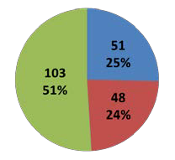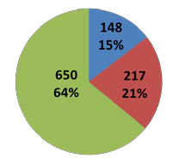

**2011 - Age Demographic**

**530**

**16%**

**693**

Eastern Cape KwaZulu Natal

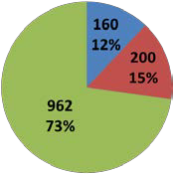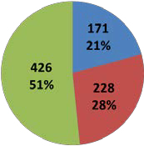

**2141**

**64%**

**20%**

**Pony Riders Juniors Adults**

Gauteng Western Province

**Eventing Data 2012 – Entries per Age Group**

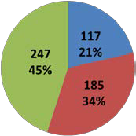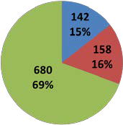

**2011 - Age Demographic**

**2359**

**64%**

**540**

**14%**

**809**

**22%**

Eastern Cape KwaZulu Natal

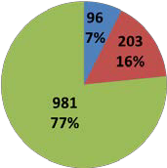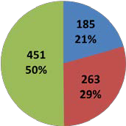

**Pony Riders Juniors Adults**

Gauteng Western Province

**2011 & 2012 Provincial Entries Comparison**

500

400

300

200

100

0

**2011 Entries by Grade**

50/60 70 80 90 100 1* 2* 3*

500

400

300

200

100

0

**2012 Entries by Grade**

50/60 70 80 90 100 1* 2* 3*

EC KZN GP WP

EC KZN GP WP

Total entries of riders in each height.

50.0%

**2011 Entries by Grade % per Province**

50.0%

**2012 Entries by Grade % per Province**

40.0%

40.0%

30.0%

30.0%

20.0%

20.0%

10.0%

10.0%

0.0%

50/60 70 80 90 100 1* 2* 3*

0.0%

50/60 70 80 90 100 1* 2* 3*

EC KZN GP WP SA

EC KZN GP WP SA

Percentage of riders in each height per year based on the total entries in the province.

**2011 Entries by Grade Average per Show**

60

50

40

30

20

10

0

50/60 70 80 90 100 1* 2* 3*

**2012 Entries by Grade Average per Show**

60

50

40

30

20

10

0

50/60 70 80 90 100 1* 2* 3*

EC KZN GP WP SA

EC KZN GP WP SA

Average number of riders in each height per year.

**Market Data Analysis**

Although the above data is not able to delve into significant granularity given the lack of data at the time of writing, it however has led to several key understandings that have had significant impact on the path forward:

***FEI 5% vs Non-FEI 95%***

There have often been an questions asked as to the reason why we need FEI in our sport, specifically from those at the lower grades who feel that they are paying for the top grades to succeed.

Specifically:

• FEI affiliation is expensive: R40,000+ per year.

• FEI athletes equate for just 5% of all entries.

• FEI cross-country courses are expensive to build.

• There is significant national administration required for FEI events and athletes.

However; without the FEI, there would be no entry point for our athletes to compete internationally, or to earn national colours. Although FEI competition might not be important to many competitors, without a goal to aim for the sport becomes meaningless and there is a lack of heroes for the lower levels to aspire towards.

In addition, the FEI have spent significant amounts of money in developing the sport of

Eventing in South Africa over the last 15 years, which can clearly be seen in:

• the quality of the venues and cross-country courses across all grades countrywide.

• the upgrading of our officials nationally.

• the upgrading of our coaching through international assistance.

FEI competition is therefore an integral part of our sport that maintains the vision and goals of our top athletes.

However; given the statistics, more effort does need to be made in taking the knowledge learned at the top levels and better infusing it through the rest of the sport to increase the number of competitors at the lower levels, which in the long term will create more international hero athletes.

Again this comes back to the balance of ‘**An Active and Winning Nation**’.

***Low-Grade + Low-Entry fee = mass participation***

During 2012, the Eastern Cape eventing committee significantly changed their entry and grades model and offered low grades at a very affordable price point for non-registered riders. This allowed riders that had not previously registered with the Eastern Cape horse society to enter the sport.

This had significant effect on the numbers, growing this sector (Ev60 & Ev70) by over 200%

in one year and making it profitable to continue to run events in Port Elizabeth.

This clearly indicates that there is a desire to participate by newcomer athletes at the very low levels, as well as an indication of the current financial barriers to enter the sport.

What remains to be seen is how many of those Ev60 and Ev70 riders convert to Ev80 over the next couple of years.

***Drop-off of Pony Riders and Juniors***

There has been a significant drop in the numbers of Pony Riders and Juniors over the last 5-

10 years, which are not necessarily reflected in the statistics, but are clearly seen in some of the Provinces where some grades are not run due to lack of entries.

This is probably due to several factors such as:

• Fast paced modern society.

o Available time.

o Lack of facilities within range of daily commute.

• Cost.

• Lack of marketing.

This has in part been addressed through SANESA who market directly to the schools and make it desirable for Children and Juniors to be involved and gain peer acknowledgment through school colours.

Unfortunately this is not having the desired effect of increasing the numbers of Pony Rider and Juniors at non-SANESA competition.

***Graded vs Non-Graded (Ev80 cross-over)***

The Ev80 distribution through all age groups is an interesting statistic in that it’s the first step on the grading platform and therefore perceived as a step above ‘training’ or non-graded competition.

This is primarily a psychological statistic that highlights the need to have goals throughout all levels of the development process for athletes to achieve.

**MARKETING/SALES STRATEGY**

Currently there is little or no eventing marketing taking place in South Africa, and a multi- fold marketing strategy needs to be put in place. In order to grow the sport, a marketing team will need to be put in place to generate excitement and energy to motivate new entrants to take part.

**Target Markets**

***Transformation market***

The transformation market is probably the largest market segment, and has various reasons for not attempting eventing as a sport:

• Unaware

• Perceived dangerous

• Perceived as a lot of effort

• Perceived as expensive

A marketing campaign needs to focus on these riders that creates a fun, exciting and safe picture of eventing at the lowest levels to entice them to enter the sport.

Areas of advertising need to be identified from multiple segments of the sport:

• Education of all levels Instructors.

• Traditional advertising

o Magazine advert placement

o Newspaper articles

o Press releases

• Electronic marketing

o Website / Facebook / Twitter

• Word of mouth

***SANESA / Pony Riders& Junior Market***

Given the decrease of schools riders (Pony Riders and Juniors) over the last few years, there needs to be focus on conversion from SANESA eventing to Eventing SA. This is much like the relationship that currently exists in School Sport feeding into Club Sport.

Analysis needs to be done to ascertain the wants and needs of the children and particularly the parents as to their motivation for attending more formal competition.

**RESEARCH AND DEVELOPMENT**

Eventing SA requires a considerable amount of work to modernise to current international standards in all sectors of the sport.

**Business structure development - Portfolio structures**

Given this, a portfolio development structure has been put into place nationally focusing on all segments of the business, allowing for experts to focus on their areas of skills and interest to best deliver.

• Rider Development

• Instructor Development

• Course Development

• Show Holding Bodies

• WEG / Olympic Team

Management

• Officials

• Safety and Security

• Rules

• Communications

• Marketing & Branding

• Merchandise

• Public Relations

• Fund Raising

• IT (Data & Internet)

The following are point form outlines of each of the intended portfolios, and will be better directed with meetings involving the individual managers and sub-committees.

***Rider Development & Management***

• Rider Development

o Grass roots → International strategy

o Local -> international placement

o Camps

o Squads

o SA Team coaching – liaising with WEG/Olympic Management Team

• Communication to riders

• Rankings

o Provincial / National

• Disciplinary action

o Management of yellow cards

• Documentation - website

o Intro to eventing

o Professional eventing

o Riding internationally

o Progression - Clear path for riders

▪ Beginner

▪ Graded

▪ Teams

▪ National teams

▪ Competing Internationally

***WEG / Olympics – Team Management***

• Rider Identification

• Part of SAEF International Affairs

• Management of Long List (Elite)

o Communications to all relevant parties

• Development

o Development of Elite riders in line with National Rider Development

Strategy

• Selection of National Coach / Chef d’Equipe / Team Manager / etc

• Communications

o SAEF / SASCOC

o FEI

o National Federations

• Management of Selection Criteria

***Coaches Development and Management***

• Coach / Instructor Identification

• Tying into ICASA accreditation strategy

o Job creation

• Levels of Coaches

o Transformation

▪ Rider recruitment strategy

o Development

o High Performance

• Documentation

o How to become an Eventing Coach

o RPL for Eventing Coaches – process

• Publication

o Accredited coaches

***Course Design & Building***

• International → internal standards alignment

• Development - Courses

o Design guidelines per level

o Overseeing of courses countrywide

• Development – people

o Course Builder development

▪ career path

o Course Designer development

• Data

o Accident review & prevention

***SHB Development & Management***

• Calender management

o National / Local

• Development of show holding bodies → CRITICAL

• Documentation for show holding bodies

o Howto's

o Organisational plans & check lists

o Organisational time lines

• Infrastructure

o Guidelines

o Shared requirements

▪ National

▪ Provincial

▪ Local

• Best practices

***Officials Development & Management***

• Development

o Levels – Provincial through to FEI

o Education

▪ Clear path and assessment criteria from level to level

o Jump Judge development

o Time keeper & Starter development

o Score keeper development

o Marshals

o Courses

o Stewards

• Management

• Public repository & management thereof

***Safety and Security***

• Documentation

o Show holding bodies

o Accident procedures

▪ Falls

▪ Fatalities

o Concussion

• Development & Education

o Courses

▪ First aid (Level 1)

• Mandatory - TD's and above

o Disaster management

• Data - analysis

o Requirements

o Fall reports – not just FEI

o Refusal reports – prevention

o Reverse Qualification

***Rules***

• Reworking of current SAEA rules into new SAEF structures

• On-going development of rules

o International alignment

o Addressing of National concerns

▪ Safety

▪ New technology

***Communication***

• National

o Website

o Facebook

o Twitter

• Provincial

o Website

o Facebook

o Twitter

• Topics

o Shows

o Eventing related – International / Local

***Marketing and Branding***

• Creation and management of a 'Eventing SA' brand

• Marketing of the brand

o Internal community (Riders in SA)

o External (general public)

o International

• Merchandising

o Design & creation

o Distribution

o Sales

• Brand Public Relations & Spokesperson

o Interviews

o National Press Releases

***Fund Raising***

• Finding the required budgeted funds

o Lottery funding management

▪ National → local distribution

o Corporate sponsorship

o International sponsorship

• National series sponsorship

***Information Technology***

• Website

o Development

▪ Site

▪ Email systems

o Infrastructure management

▪ Portfolio communication requirements and sections

o National to provincial

▪ Structural setup & management

▪ Syndication of data

o Backup procedures

• Scoring systems

o Development & Support of standardised electronic scoring

• Long term data convergence

o Direct linking of all data

▪ Online scoring systems

• Basic - scorekeeper upload

• Advanced – real time jump judge

▪ Real time rider rankings & QR management

o TD reporting

▪ Real time TD reporting systems

o Data analysis systems

▪ Accident reporting

▪ Course analysis

• Technology investigation

o Social media applications

o Public forums

**New product development**

With the changing socio economic climate and urbanisation, eventing needs to create new products that attract and inspire more athletes to participate. These products need to focus on the transformation part of the equestrian market, allowing riders to easily experience the sport and ultimately setting them on the path of development to becoming an Elite Eventing Athlete.

***New grades***

The current grades are the cornerstone of our sport and through recent readjustment have better fallen in line with international standards allowing eventing athletes to progress up the grades to international competition.

Although this focus has primarily been on existing athletes within the sport and the development phase, it does not cater well to those wanting to enter the sport and therefore has inadvertently created a barrier to entry.

By formalising the Ev70 and Ev60 grades into eventing this does several things;

• creates a path for transformation.

• reduces the barrier to entry.

• creates formalised rules and specifications that assist with the safe running for previously informal competition.

• creates an additional revenue stream.

There is concern that this will allow athletes to further reduce standards by no longer upgrading from areas of comfort (i.e. from Ev70 to Ev80). However; with careful planning, the Ev60 and Ev70 need to be targeted at a level that allows the competitor to experience the basics of the sport and then wish to climb further up the development cycle to the formal competition of Ev80 and above.

For example Ev60 could simply be a 750m course comprising of 8-10 fences of zero technicality that allows riding school pupils to safely navigate (within instructor view) cross country type fences in order to experience the sport, however; it leaves clear knowledge that there is a lot more available.

These grades do not require Qualifying Rounds and athletes are easily able to upgrade to

Ev80 as they see fit.

***Inter Club Team Competition***

With the implementation of the Club system through the new SAEF structures, this has paved way to Inter-Club competition within each of the provinces, and possibly even a national club championship.

***Express Eventing***

Express Eventing, Eventing Classic, Winter Classic or Jump-Cross as it’s informally know by different names in each province throughout South Africa has never formally been adopted by Eventing as a part of the sport even though it utilises eventing type fences and rules.

By formalising Express Eventing, we’re able to set National rules and specifications that can lead to a national series, and in addition adds another entry point into the sport.

In addition this allows for excellent opportunity to train officials as well as creating another revenue stream into the sport.

***One Day Series***

With today’s fast paced society, the ‘One Day’ event is fast becoming extremely popular with athletes and family alike. This allows families to enjoy eventing without giving up their entire weekend.

The recent Kwa-Zulu Natal One Day series has been extremely successful and helped to rejuvenate eventing in the province, and much like One Day cricket it makes it much more exciting for the crowds and helps to create atmosphere and therefore sponsorship.

There is an expressed interest by the current series sponsor to take the event nationwide.

***SANESA***

Better integration with SANESA needs to be reviewed with regards to better creating a sustainable development path for athletes graduating from SANESA competition to formal competition.

This will increase the number of Pony Rider and Junior competitors at normal shows and create a better future for eventing nationwide.

**STAFFING AND OPERATIONS**

**NATIONAL MANAGEMENT STRUCTURE**

Eventing South Africa will require a centralised office to manage the sport, however given that there are only around 450 eventers in South Africa there is not a need for significant office overheads and staffing.

**Management Organisation Chart**

Board of Directors

Executive Committee

GM CEO

Portfolio Portfolio Portfolio Portfolio Portfolio Portfolio

GP KZN WP EC MP FS

LP NC NW

Portfolio Portfolio Portfolio Portfolio Portfolio Portfolio

In order to achieve the goals of eventing, an attempt has been made to separate the management of the sport from any form of politics. This has been done by creating a Board of Directors that have been voted in by the members either nationally or provincially who then appoint a CEO. This allows for the appointment of the best person for the job, and not necessarily the most popular person.

The CEO is then able to appoint various portfolio teams (with the Boards approval) to take on the tasks required to run the business of Eventing. The CEO is backed up by the General Manager, the only employed person in the structure, to on a daily basis manage the sport.

This structure gives the best of both worlds, namely; direction from the members (via the board) and implementation by individuals with the right expertise.

**STAFFING REQUIREMENTS**

Eventing South African will require an employed staff member (the General Manager) to do the following:

• Membership management.

• Record keeping and accounting.

• Approval of show schedules.

• Approval of show entries.

• Grading of show results.

• Portfolio assistance:

o Project Management.

o Type-setting.

o Planning assistance.

▪ Budgeting.

▪ Timing.

▪ Co-ordination.

• Communications / Switchboard. (worldwide email point of contact)

• Website manager.

Someone with a wide variety of skills, and fluent in the Equestrian market management space will be required.

A full job description and call for CV’s will be issued shortly.

**OPERATIONS REQUIREMENTS**

Eventing South Africa will need offices and facilities to manage the business from a centralised location in South Africa, and will have the following costs involved:

Premises

• We will seek to share office space within the SAEF structure. This will reduce costs given a shared environment, as well as open direct channels of communication with the SAEF.

Equipment required

o Laptop computer

o Monitor

o Lazer printer/fax/copier

o Video conference webcam

o Desk / Chair / Filing cabinets

Infrastructure

• Telephone

• ADSL – (4Mb+) & ADSL Bandwidth

• Mobile phone

• 3G backup

• Offsite backup – Dropbox (paid 100Gb)

• Insurance

Communications facilities

• Internet meeting / conference facilities - WebEx

**FINANCIAL PROJECTIONS**

The financial projections are based on recent historical data, as well as review of several income models. They do not currently include the income from the intended new products, but rather cover the basics to ensure the continued running of the sport .

**REVENUE SOURCES**

There are 2 primary revenue sources for Eventing South Africa:

• Subscriptions

This takes the form of yearly association fees that are payable prior to competing in any competition. These are administration based costs and relate both to riders and horses individually.

o Riders

▪ Fees will be based on age groups, with reduced fees for Pony Riders

and Juniors.

o Horses

▪ Fees are based on the grade at which the horse competes.

• Entry Levies

These are non-refundable levies added to competition entry fees.

o These are based on the grade of competition per entry.

**Annual Subscription Model**

The annual subscription model follows a once off fee that all Athletes (Riders & Horses) pay to compete in the sport.

• Pros

o Upfront income - Reduced business risk, given guaranteed required income.

• Cons

o Reduced participation incentive.

Riders less inclined to want to participate or ‘try’ the sport given steep financial requirements to participate.

o Riders are penalised by non-usage.

**Entry Levy Model**

The entry levy model refers to a levy imposed on every eventing entry in South Africa.

• Pros

o Riders are able to enter the sport with no barrier to entry, and therefore are more inclined to try it.

• Cons

o Higher business risk – Entries are an on-going income stream that are not guaranteed, and therefore can put the national office at risk in a cashflow model, or where an outside influence directly affects numbers of show entries (i.e. AHS outbreaks).

o High usage riders may feel that they are paying more than others, even though they are benefiting the most.

o The direct weekend price entry point can be a concern when directly comparing it to other disciplines.

**Balanced Model**

Eventing South Africa has implemented a balanced model that is a mixture of the Annual Subscription Model and Entry Levy Model, and attempts to benefit from the best of both models.

This still allows a reduced entry to the sport at the low grades, provides a financial buffer to reduce the risk on the national office, more directly proportions administration costs.

**PRICING STRUCTURE**

The following outlines further considerations that were made in deducing the Eventing

South Africa product price points.

**Pricing Influences**

The Eventing SA price point has had 2 major influences namely:

• Multi-Discipline MOU

At the SAEA bosberaad, a MOU was agreed upon with the Provincial committees to remove a barrier to entry for Multi-Discipline athletes so that they would not be penalised through affiliate fees with multiple Associations. The reason behind this is that there is consensus that exposure to Multi-Disciplines creates better athletes that are able to cope better with all equestrian disciplines, and ultimately become better riders. This also reduces specialisation in young athletes and allows them to find the discipline that they truly excel in.

• Household price point

Given the current economic climate, each household only has a set amount of money available each year (and month) to spend on their sport. In addition there was another MOU with the Provinces that their disciplines should not extend their costs past the current costs that athletes are currently paying. Given that there is more administration and project management in the new structure, this is not completely possible, however; Eventing has kept this at the forefront in designing the new pricing model.

The above points have had positive knock-on effects in that the proposed pricing model:

• is extremely accessible to newcomers to the sport.

• keeps costs down for occasional competitors, allowing athletes to compete as their income allows them to.

• works very well in small and large provinces alike.

• attempts to proportion administration costs and usage.

This however does have certain risks attached in that in order to administer the sport and complete the intended upgrade projects utilising a volunteer base, there are both yearly and monthly expenses that need to be paid. Given that the income model is based largely on usage, the sport is at risk should conditions present themselves where there is a reduction of the number of competitions, competitors and entries.

**Pricing**

The following is an outline of the South African Eventing pricing structure:

**Yearly Subscription**

***Riders***

Pony Riders R 100.00

Juniors R 150.00

Adults R 200.00

***Horses***

50/60 R 100.00

70 R 150.00

80 R 100.00

90 R 250.00

100 R 300.00

1* R 500.00

2* R 1000.00

3* R 1500.00

**Entry Levies (per competition entry)**

50/60 R 50.00

70 R 75.00

80 R 100.00

90 R 125.00

100 R 150.00

1* R 250.00

2* R 500.00

3* R 750.00

This allows for riders of all ages to enter the sport for R350.00 or less at the lowest grades and to be able to continue competing at less than the cost of a MacDonald’s meal per show.

On the higher levels, the competitors are charged a significantly larger amount that is in proportion to the amount of administration required, and also reflects the additional value that they receive through the benefits that FEI and international competition brings to South Africa.

**LOTTERY FUNDING**

In addition to direct funding, Eventing SA can qualify for up R1,000,000.00 in lottery funding every year, to be determined by:

• Development projects that fall within certain categories:

o Athlete development

o Instructor/coach development

o Officials development

o Capacity/infrastructure development

This funding  **cannot** be relied upon, and therefore does not make up part of the budget.

Each of the development Portfolios will apply for funding based on specific projects that fall within Lottery requirements and can be delivered upon within yearly timetables. These projects will be monitored by the General Manager and overseen by the CEO.

Additional funding is available depending on achieving goals within a 20 year vision plan.

**KEY ASSUMPTIONS OF CASHFLOW MODEL**

• 40% of annual subscriptions will be received in the first months of the year, with the remaining 60% being received over a further 6 months.

• Figures are based on historical information of entries from August 2011 to July 2012.

|  |  |  |  |  |
| --- | --- | --- | --- | --- |
| **Income ‐ Pay to Play (per entry) Number Amount** | | **Totals** | **Aug‐11 Sep‐11 Oct‐11 Nov‐11 Dec‐11 Jan‐12 Feb‐12 Mar‐12 Apr‐12 May‐12 Jun‐12 Jul‐12** | 0.60%  0.39%  0.75%  2.66%  2.91%  7.76%  4.42%  6.38%  17.85%  4.53%  5.14%  14.34%  4.77%  7.32%  6.20%  3.54%  1.11%  3.29%  2.42%  0.58%  3.05%  0.00% |
| 2011/2012 data PR50/60 139  J50/60 97  A50/60 182  PR70 333  J70 400  A70 1003  PR80 391  J80 588  A80 1685  PR90 337  J90 385  A90 1093  J100 284  A100 500  ACNC1* 241  ACIC1* 123  ACCI1* 44  ACNC2* 68  ACIC2* 50  ACCI2* 31  ACIC3* 25  ACCI3* 0 | R 50.00  R 50.00  R 50.00  R 75.00  R 75.00  R 75.00  R 100.00  R 100.00  R 100.00  R 125.00  R 125.00  R 125.00  R 150.00  R 150.00  R 250.00  R 250.00  R 250.00  R 500.00  R 500.00  R 500.00  R 750.00  R 750.00 | R 3 100.00  R 2 000.00  R 3 850.00  R 13 725.00  R 15 000.00  R 40 050.00  R 22 800.00  R 32 900.00  R 92 100.00  R 23 375.00  R 26 500.00  R 74 000.00  R 24 600.00  R 37 800.00  R 32 000.00  R 18 250.00  R 5 750.00  R 17 000.00  R 12 500.00  R 3 000.00  R 15 750.00  R ‐ | R 0.00 R 0.00 R 0.00 R 550.00 R 0.00 R 0.00 R 800.00 R 550.00 R 0.00 R 300.00 R 100.00 R 800.00  R 0.00 R 0.00 R 0.00 R 150.00 R 0.00 R 0.00 R 550.00 R 250.00 R 0.00 R 300.00 R 150.00 R 600.00  R 0.00 R 0.00 R 0.00 R 1 000.00 R 0.00 R 0.00 R 1 050.00 R 400.00 R 0.00 R 400.00 R 250.00 R 750.00  R 1 275.00 R 1 125.00 R 0.00 R 2 100.00 R 225.00 R 975.00 R 2 925.00 R 1 575.00 R 1 200.00 R 750.00 R 375.00 R 1 200.00  R 900.00 R 1 500.00 R 0.00 R 1 200.00 R 375.00 R 750.00 R 3 075.00 R 2 400.00 R 1 800.00 R 900.00 R 825.00 R 1 275.00  R 2 625.00 R 3 525.00 R 1 125.00 R 3 525.00 R 2 250.00 R 2 400.00 R 6 150.00 R 7 725.00 R 4 575.00 R 2 400.00 R 1 800.00 R 1 950.00  R 1 700.00 R 2 700.00 R 3 400.00 R 2 500.00 R 400.00 R 700.00 R 2 500.00 R 2 300.00 R 2 100.00 R 1 500.00 R 2 100.00 R 900.00  R 2 300.00 R 3 000.00 R 4 400.00 R 3 300.00 R 2 400.00 R 200.00 R 3 900.00 R 2 600.00 R 4 300.00 R 2 900.00 R 1 300.00 R 2 300.00  R 5 000.00 R 8 100.00 R 14 400.00 R 10 300.00 R 2 100.00 R 3 500.00 R 10 100.00 R 13 300.00 R 11 900.00 R 4 900.00 R 4 000.00 R 4 500.00  R 1 375.00 R 2 750.00 R 1 625.00 R 1 750.00 R 0.00 R 250.00 R 2 500.00 R 3 250.00 R 3 500.00 R 2 000.00 R 3 875.00 R 500.00  R 2 500.00 R 3 250.00 R 1 000.00 R 2 250.00 R 2 000.00 R 250.00 R 2 875.00 R 3 625.00 R 2 625.00 R 1 750.00 R 375.00 R 4 000.00  R 9 250.00 R 8 750.00 R 4 250.00 R 7 750.00 R 3 750.00 R 3 375.00 R 7 125.00 R 10 625.00 R 7 500.00 R 4 375.00 R 2 375.00 R 4 875.00  R 1 050.00 R 2 850.00 R 3 900.00 R 2 400.00 R 4 800.00 R 0.00 R 150.00 R 1 500.00 R 3 150.00 R 1 050.00 R 1 500.00 R 2 250.00  R 1 950.00 R 3 450.00 R 7 800.00 R 4 200.00 R 0.00 R 1 350.00 R 2 850.00 R 3 600.00 R 6 150.00 R 2 250.00 R 1 950.00 R 2 250.00  R 0.00 R 3 000.00 R 2 000.00 R 0.00 R 0.00 R 3 250.00 R 5 750.00 R 0.00 R 8 750.00 R 1 250.00 R 2 750.00 R 5 250.00  R 5 000.00 R 3 500.00 R 0.00 R 6 750.00 R 0.00 R 0.00 R 0.00 R 0.00 R 3 000.00 R 0.00 R 0.00 R 0.00  R 0.00 R 0.00 R 5 500.00 R 0.00 R 0.00 R 0.00 R 0.00 R 0.00 R 0.00 R 0.00 R 250.00 R 0.00  R 0.00 R 0.00 R 0.00 R 0.00 R 0.00 R 0.00 R 0.00 R 0.00 R 1 500.00 R 0.00 R 3 500.00 R 12 000.00  R 4 000.00 R 4 000.00 R 4 500.00 R 0.00 R 0.00 R 0.00 R 0.00 R 0.00 R 0.00 R 0.00 R 0.00 R 0.00  R 1 000.00 R 0.00 R 0.00 R 0.00 R 0.00 R 0.00 R 0.00 R 0.00 R 0.00 R 0.00 R 2 000.00 R 0.00  R 3 750.00 R 5 250.00 R 6 750.00 R 0.00 R 0.00 R 0.00 R 0.00 R 0.00 R 0.00 R 0.00 R 0.00 R 0.00  R 0.00 R 0.00 R 0.00 R 0.00 R 0.00 R 0.00 R 0.00 R 0.00 R 0.00 R 0.00 R 0.00 R 0.00 |
|  | |
| **Total Pay To Play Income** | | **R 516 050.00** | **R 43 675.00 R 56 750.00 R 60 650.00 R 49 725.00 R 18 300.00 R 17 000.00 R 52 300.00 R 53 700.00 R 62 050.00 R 27 025.00 R 29 475.00 R 45 400.00** | **R 516 050.00** |
| **Income ‐ Annual Subscription Riders Number Amount** | | **Total** | **40% 25% 15% 10% 5% 3% 2%** | 7.68%  18.37%  73.95% |
| 2012 data Pony Riders 64  Juniors 102  Adults 308 | R 100.00  R 150.00  R 200.00 | R 6 400.00  R 15 300.00  R 61 600.00 | R 2 560.00 R 1 600.00 R 960.00 R 640.00 R 320.00 R 192.00 R 128.00  R 6 120.00 R 3 825.00 R 2 295.00 R 1 530.00 R 765.00 R 459.00 R 306.00  R 24 640.00 R 15 400.00 R 9 240.00 R 6 160.00 R 3 080.00 R 1 848.00 R 1 232.00 |
|  | |
| **Rider totals 474** | | **R 83 300.00** | **R 33 320.00 R 20 825.00 R 12 495.00 R 8 330.00 R 4 165.00 R 2 499.00 R 1 666.00 R 0.00 R 0.00 R 0.00 R 0.00 R 0.00** | **R 83 300.00** |
| **Income ‐ Annual Subscription Horses Number Amount** | | **Total** | **40% 25% 15% 10% 5% 3% 2%** | 3.64%  12.35%  20.58%  16.30%  10.09%  11.66%  17.15%  8.23% |
| 2011/2012 data 50/60 53  70 120  80 150  90 95  100 49  1* 34  2* 25  3* 8 | R 100.00  R 150.00  R 200.00  R 250.00  R 300.00  R 500.00  R 1 000.00  R 1 500.00 | R 5 300.00  R 18 000.00  R 30 000.00  R 23 750.00  R 14 700.00  R 17 000.00  R 25 000.00  R 12 000.00 | R 2 120.00 R 1 325.00 R 795.00 R 530.00 R 265.00 R 159.00 R 106.00  R 7 200.00 R 4 500.00 R 2 700.00 R 1 800.00 R 900.00 R 540.00 R 360.00  R 12 000.00 R 7 500.00 R 4 500.00 R 3 000.00 R 1 500.00 R 900.00 R 600.00  R 9 500.00 R 5 937.50 R 3 562.50 R 2 375.00 R 1 187.50 R 712.50 R 475.00  R 5 880.00 R 3 675.00 R 2 205.00 R 1 470.00 R 735.00 R 441.00 R 294.00  R 6 800.00 R 4 250.00 R 2 550.00 R 1 700.00 R 850.00 R 510.00 R 340.00  R 10 000.00 R 6 250.00 R 3 750.00 R 2 500.00 R 1 250.00 R 750.00 R 500.00  R 4 800.00 R 3 000.00 R 1 800.00 R 1 200.00 R 600.00 R 360.00 R 240.00 |
|  | |
| **Horse totals 534** | | **R 145 750.00** | **R 58 300.00 R 36 437.50 R 21 862.50 R 14 575.00 R 7 287.50 R 4 372.50 R 2 915.00 R 0.00 R 0.00 R 0.00 R 0.00 R 0.00** | **R 145 750.00** |
|  | |  |  |  |
| **Subscription Income** | | **R 229 050.00** | **R 91 620.00 R 57 262.50 R 34 357.50 R 22 905.00 R 11 452.50 R 6 871.50 R 4 581.00 R 0.00 R 0.00 R 0.00 R 0.00 R 0.00** | **R 229 050.00** |
|  | |  |  |  |
| **Income Total Income Total** | | **R 745 100.00** | **R 135 295.00 R 114 012.50 R 95 007.50 R 72 630.00 R 29 752.50 R 23 871.50 R 56 881.00 R 53 700.00 R 62 050.00 R 27 025.00 R 29 475.00 R 45 400.00** | **R 745 100.00** |
|  | |  |  |  |

|  |  |  |  |  |
| --- | --- | --- | --- | --- |
| **Expenses Monthly Cost** | | **Total Cost** |  |  |
|  | | R ‐325 000.00  R ‐60 000.00  R ‐6 000.00  R ‐48 000.00  R ‐1 200.00  R ‐3 000.00  R ‐40 000.00  R ‐24 000.00  R ‐90 000.00  R ‐19 550.00  R ‐1 250.00  R ‐9 000.00  R ‐6 000.00  R ‐6 000.00  R ‐7 500.00  R ‐7 500.00  R ‐7 500.00  R ‐7 500.00  R ‐500.00  R ‐5 000.00  R ‐5 000.00  R ‐7 500.00 | R ‐25 000.00 R ‐25 000.00 R ‐25 000.00 R ‐25 000.00 R ‐50 000.00 R ‐25 000.00 R ‐25 000.00 R ‐25 000.00 R ‐25 000.00 R ‐25 000.00 R ‐25 000.00 R ‐25 000.00  R ‐5 000.00 R ‐5 000.00 R ‐5 000.00 R ‐5 000.00 R ‐5 000.00 R ‐5 000.00 R ‐5 000.00 R ‐5 000.00 R ‐5 000.00 R ‐5 000.00 R ‐5 000.00 R ‐5 000.00  R ‐500.00 R ‐500.00 R ‐500.00 R ‐500.00 R ‐500.00 R ‐500.00 R ‐500.00 R ‐500.00 R ‐500.00 R ‐500.00 R ‐500.00 R ‐500.00  R ‐4 000.00 R ‐4 000.00 R ‐4 000.00 R ‐4 000.00 R ‐4 000.00 R ‐4 000.00 R ‐4 000.00 R ‐4 000.00 R ‐4 000.00 R ‐4 000.00 R ‐4 000.00 R ‐4 000.00  R ‐100.00 R ‐100.00 R ‐100.00 R ‐100.00 R ‐100.00 R ‐100.00 R ‐100.00 R ‐100.00 R ‐100.00 R ‐100.00 R ‐100.00 R ‐100.00  R ‐250.00 R ‐250.00 R ‐250.00 R ‐250.00 R ‐250.00 R ‐250.00 R ‐250.00 R ‐250.00 R ‐250.00 R ‐250.00 R ‐250.00 R ‐250.00  R ‐40 000.00  R ‐4 000.00 R ‐4 000.00 R ‐4 000.00 R ‐4 000.00 R ‐4 000.00 R ‐4 000.00  R ‐7 500.00 R ‐30 000.00 R ‐7 500.00 R ‐7 500.00 R ‐30 000.00 R ‐7 500.00  R ‐19 550.00  R ‐1 250.00  R ‐750.00 R ‐750.00 R ‐750.00 R ‐750.00 R ‐750.00 R ‐750.00 R ‐750.00 R ‐750.00 R ‐750.00 R ‐750.00 R ‐750.00 R ‐750.00  R ‐500.00 R ‐500.00 R ‐500.00 R ‐500.00 R ‐500.00 R ‐500.00 R ‐500.00 R ‐500.00 R ‐500.00 R ‐500.00 R ‐500.00 R ‐500.00  R ‐500.00 R ‐500.00 R ‐500.00 R ‐500.00 R ‐500.00 R ‐500.00 R ‐500.00 R ‐500.00 R ‐500.00 R ‐500.00 R ‐500.00 R ‐500.00  R ‐7 500.00  R ‐7 500.00  R ‐7 500.00  R ‐7 500.00  R ‐500.00  R ‐5 000.00  R ‐5 000.00  R ‐7 500.00 |
| Staff  General Manager Salary  Office Rental Supplies  Telephone(s) & Internet  Dropbox  WebEx FEI Annual Fees Drug testing Travel  Insurance  Members 782  Officials 50  Limited Liability  Office  Accounting  Audit Fees  Startup Costs Laptop Printer/Copier/Scanner/Fax Office Furniture  Telkom Rent deposit Office Supplies Conference Phone | R ‐25 000.00  R ‐5 000.00  R ‐500.00  R ‐4 000.00  R ‐100.00  R ‐250.00  R ‐40 000.00  R ‐4 000.00  R ‐25.00  R ‐25.00  R ‐750.00  R ‐500.00  R ‐500.00  R ‐7 500.00  R ‐7 500.00  R ‐7 500.00  R ‐7 500.00  R ‐500.00  R ‐5 000.00  R ‐5 000.00  R ‐7 500.00 |
|  | |
| **Expense Total Expense Total** | | **R ‐687 000.00** | **R ‐105 400.00 R ‐80 600.00 R ‐74 100.00 R ‐40 600.00 R ‐69 100.00 R ‐40 600.00 R ‐44 100.00 R ‐40 600.00 R ‐66 600.00 R ‐40 600.00 R ‐44 100.00 R ‐40 600.00** | R ‐687 000.00 |
|  | |  |  |  |
| **Monthly Profit / Loss Profit / Loss** | | **R 58 100.00** | **R 29 895.00 R 33 412.50 R 20 907.50 R 32 030.00 R ‐39 347.50 R ‐16 728.50 R 12 781.00 R 13 100.00 R ‐4 550.00 R ‐13 575.00 R ‐14 625.00 R 4 800.00** | R 58 100.00 |
|  | | Minimum |  |  |
| **CashFlow CashFlow** | | **R 29 895.00** | **R 29 895.00 R 63 307.50 R 84 215.00 R 116 245.00 R 76 897.50 R 60 169.00 R 72 950.00 R 86 050.00 R 81 500.00 R 67 925.00 R 53 300.00 R 58 100.00** |  |
|  | |  |  |  |